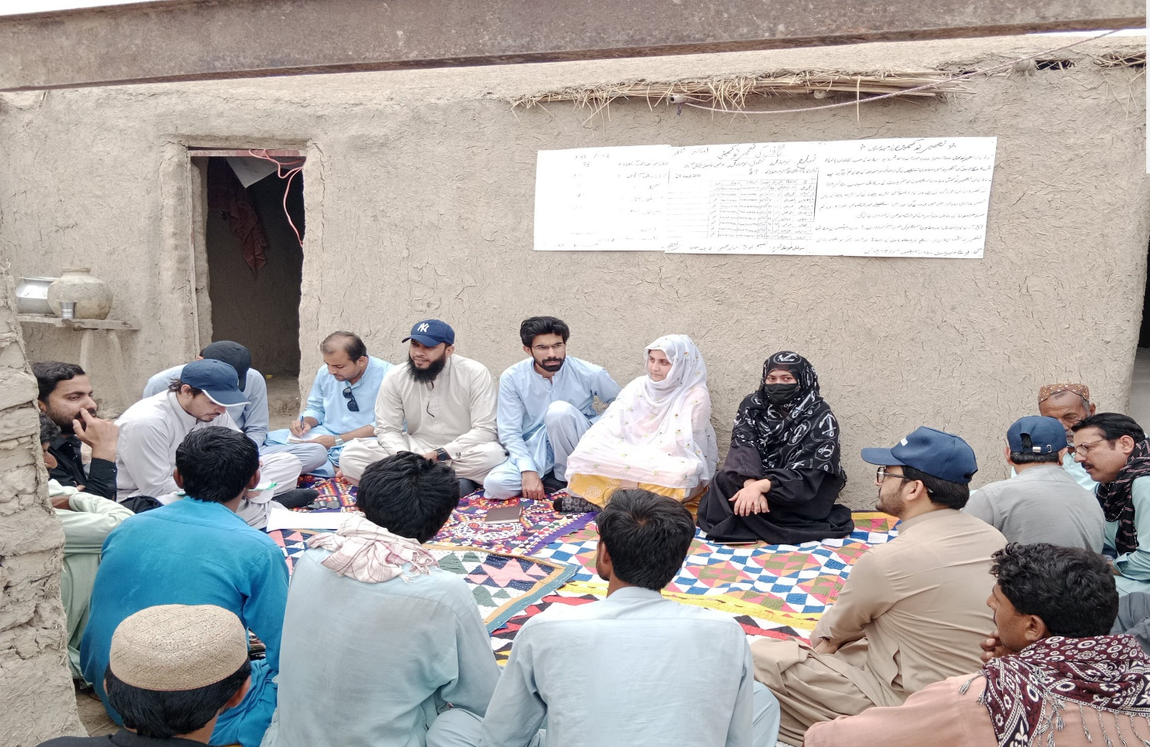
Field Visit Report
FPMU Team
5/19/25

Contents
Executive Summary 2
Field Visits Details 4
1. District Naseerabad 4
Community Mobilization: 4
Construction Progress: 4
Implementing Partner (IP) Performance: 4
Village Reconstruction Committees (VRCs): 5
2. District Sohbatpur 6
Community Mobilization: 6
Construction Work: 6
Village Reconstruction Committees (VRCs): 7
3. District Usta Muhammad 8
Community Mobilization: 8
Construction Work: 8
Village Reconstruction Committees (VRCs): 8
4. District Jaffarabad 9
Community Mobilization: 9
Construction Work: 9
Village Reconstruction Committees (VRCs): 9
5. District Kachhi 10
Community Mobilization: 10
Construction Work: 10
Village Reconstruction Committees (VRCs): 10
Recommendations: 11

Executive Summary
From May 7 to 10, 2025, the Federal Project Management Unit (FPMU) team comprising the Senior Strategic Specialist, Monitoring & Evaluation Specialist, Housing Specialist, Infrastructure Specialist, Finance Officer, and supporting Associates and Assistants—undertook comprehensive monitoring visits across five key districts under the Housing Reconstruction Unit of the Integrated Flood Resilience and Adaptation Project (IFRAP): Naseerabad, Sohbatpur, Usta Muhammad, Jaffarabad, and Kachhi.
May 7, 2025: The team traveled from Quetta to Naseerabad to initiate field monitoring activities and coordinated with the Implementing Partner (IP) teams to organize and conduct the planned field visits effectively.
May 8, 2025: Team attended Stakeholder Conference, After Conference FPMU along with HRU team visited Jafferabad construction sites. Further, FPMU team also visited District Usta Muhammad.
May 9, 2025: The team split into groups to cover: Naseerabad, Jaffarabad and Sohbatpur
May 10, 2025: Monitoring activities were conducted in District Kachhi (Haji Shar), with a focus on construction progress, banking access, and IP engagement.
May 12, 2025: A comprehensive debriefing session was conducted with the HRU team in Quetta to share key findings, observations, and recommendations based on the field visit.
The primary objectives of the mission were to assess construction progress, engage with Implementing Partners (IPs), evaluate the performance of Village Reconstruction Committees (VRCs), and coordinate with local banks on field-level disbursement processes. While most beneficiaries demonstrated an understanding of the tranche-based disbursement mechanism, several operational and contextual challenges hindered overall VRC understanding. Weak coordination between IPs and banks led to delays in fund withdrawals and poor communication in Kachi & Sohbatpur districts. Additional field-level constraints included water scarcity, inadequate skilled labor, and distant banking infrastructure, all of which impacted construction timelines and community mobilization.
The Housing Reconstruction Unit (IFRAP) Balochistan, in collaboration with Islamic Relief Pakistan, organized a pivotal Stakeholder Conference in Naseerabad and Jaffarabad (Lots 7 & 8) to advance post-disaster reconstruction efforts. The event emphasized transparency, collaboration, and community-led development. CEO Mr. Rashid Razzaq reaffirmed the government’s commitment by stating, “We’re not just rebuilding homes but restoring communities with dignity and resilience.” The conference brought together government officials, political leadership, community leaders, beneficiaries, and implementing partners to celebrate key milestones, strengthen accountability, and accelerate progress. Highlights of the event included the distribution of Completion Certificates to families with fully reconstructed homes, the disbursement of financial cheques to beneficiaries nearing completion of construction, and the recognition of outstanding contributions through souvenirs and performance.
Construction progress varies by district. While all beneficiaries had received their first tranche, disbursement of subsequent tranches was considerably delayed. Many of houses progressed to the plinth and lintel stages, with the most substantial progress observed in Jaffarabad and Naseerabad. However, delays were widespread due to procedural bottlenecks, limited mason availability, scarcity of water. Daily bank withdrawal rates ranged from 10 beneficiaries in Haji Shar to 70 in Naseerabad and 100 in Jaffarabad.
VRC performance varied across districts. In Jaffarabad, Sohbatpur, and Usta Muhammad, VRCs demonstrated strong engagement and played an active role in supporting project implementation. Conversely, Kachi, performance was hindered by limited training and the geographic dispersion of committee members, which negatively impacted coordination and effectiveness. The absence of visible Grievance Redress Mechanism (GRM) signage in communities further restricted beneficiary access to complaint resolution channels. Community ownership was particularly commendable, with the average time to complete the plinth stage across all districts being just 5 to 6 days, reflecting the dedication and urgency of the beneficiaries. The validation and selection of beneficiaries for account opening and housing support were undertaken in parallel, based on well-defined vulnerability criteria to ensure that the most affected households were prioritized and construction could begin promptly. However, due to the emergency nature of the intervention, geographic proximity could not be fully considered when forming Village Reconstruction Committees (VRCs). Furthermore, the limited number of housing grants available made it infeasible to provide coverage within a single locality. As a result, selected beneficiaries were scattered across different areas, which limited the formation and functionality of cohesive, community-based VRCs.
To ensure timely achievement of project targets, priority should be given to houses that have already completed or are nearing completion of the plinth stage for the next tranche disbursement. At the same time, continued efforts are needed to push Partner Implementing Partners (PIPs) and banks to increase the rate of daily withdrawals. Strengthening coordination between PIPs and banking institutions is equally critical to resolve pending issues, facilitate smoother disbursements, and accelerate construction progress across all targeted areas.

Field Visits Details

District Naseerabad
Project Implementation Partner (PIP): Islamic Relief
Lot # 7

Community Mobilization:
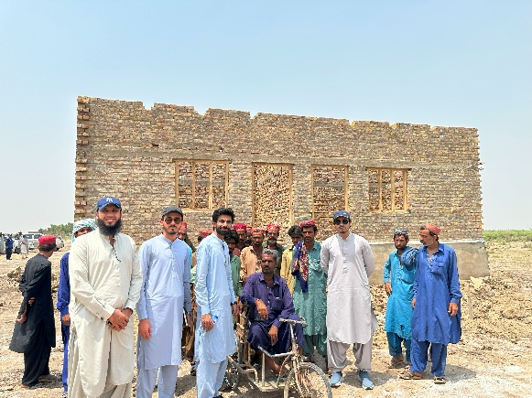
In UC Manjhoshuri and other villages of District Naseerabad, while beneficiaries were generally aware of the tranche-based disbursement system, community mobilization efforts were hindered by several operational and communication barriers. These issues were largely the result of limited coordination among the Implementing Partner (Islamic Relief – Lot #07) and banks Beneficiaries reported not receiving SMS alerts from banks, resulting in confusion and congestion during withdrawals. The absence of joint field visits by the IP, banks, and HRU further contributed to mixed messaging and delayed processes. Additionally, there was a lack of visible signage related to the Grievance Redress Mechanism (GRM), leaving beneficiaries unsure of how to report issues such as biometric mismatches or payment delays.

Construction Progress:
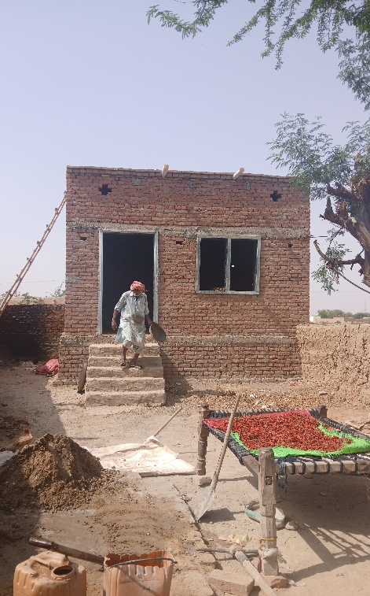
By June 2025, a total of 2,331 housing units/beneficiaries were targeted under the housing subsidy grant in Naseerabad. All beneficiaries had received the first tranche, while 1,489 beneficiaries received the second tranche, 626 the third, and only two beneficiaries had received the fourth tranche. Construction progress aligned with the disbursement trend approximately 1,631 houses had reached the plinth level, 857 the lintel stage, and 61 progressed to the roof level. The pace of construction was influenced by contextual challenges such as the shortage of skilled labor and ongoing water scarcity in the region.
Currently, the average daily withdrawal rate from banks is around 70 beneficiaries. To achieve the target of completing disbursements for all 2,331 households by June 2025, approximately 4,876 withdrawals are still required, necessitating an average of 147 withdrawals per day. This reflects a significant operational delay in disbursement, primarily due to the limited daily processing capacity at the bank level.

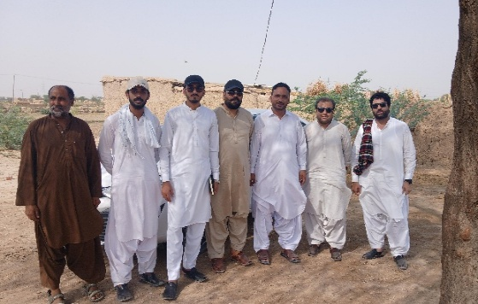
Implementing Partner (IP) Performance:
The Implementing Partner’s (IP) performance in Naseerabad demonstrated commitment to field operations; however, there appears to be a disconnect in aligning field progress with the logical requirements for timely completion. Specifically, the current average of 70 daily bank withdrawals is not being factored into the planning, which undermines the feasibility of meeting the overall target. Without structured coordination to accelerate disbursements and align documentation with withdrawal timelines, achieving the target within the stipulated period remains uncertain.

Village Reconstruction Committees (VRCs):
The VRC in District Naseerabad remained functional, their ability to conduct regular meetings and ensure active community engagement was hindered by the wide geographic dispersion of their members.

District Sohbatpur
Project Implementation Partner (PIP): Balochistan Rural Support Program
Lot # 10

Community Mobilization:
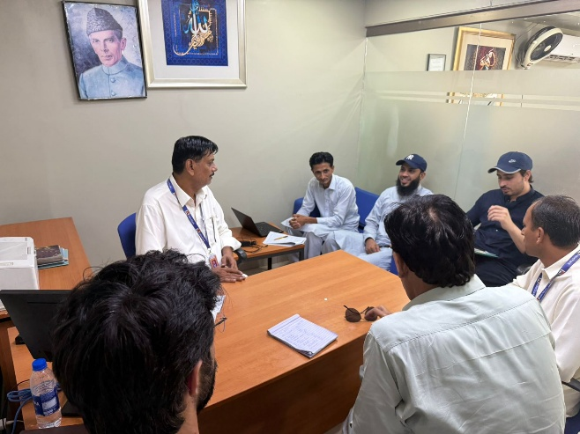
In District and nearby villages, community awareness regarding tranche disbursements was found to be satisfactory. However, payment delays were observed for 20 beneficiaries due to unresolved biometric verification issues. Additionally, the Implementing Partner (IP) did not submit photographic evidence in a timely manner, further impacting tranche approvals. There was also no clear protocol in place for addressing cases involving deceased beneficiaries, which led to procedural bottlenecks. Water availability was reported as another significant challenge affecting construction progress. Coordination between the IP field team and their management appeared weak, as no concrete decisions had been made over the past 15 days to resolve the biometric and deceased beneficiary cases, hindering overall progress. Moreover, it was noted that 82 beneficiaries had yet to receive their first tranche, highlighting a serious lag in disbursement.
A meeting was held by the FPMU team with the local bank representatives, during which the bank assured that they would process 35 to 40 withdrawals per day moving forward. This commitment reflects a gap in coordination between the IP and the bank, suggesting that earlier delays could have been mitigated through more proactive engagement by the IP team.

Construction Work:
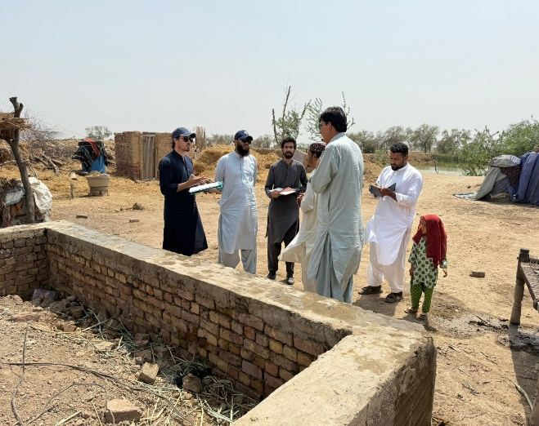
By June 2025, a total of 441 housing units/beneficiaries were targeted under the housing subsidy grant in Sohbatpur. Of these, 324 beneficiaries had received the first tranche, while 67 were approved for the second tranche. Additionally, four cases were pending due to the need for legal heir processing following the death of the original beneficiaries. Construction progress corresponded with the pace of disbursements, with approximately 130 houses completed up to the plinth level and 30 reaching the lintel stage. The overall progress was influenced by field-level challenges, including delays in documentation and limited logistical capacity.
Currently, the average daily withdrawal rate from banks is around 20 beneficiaries. To meet the target of completing construction for all 441 houses by June 2025, a total of 1,373 withdrawals are still required. This would necessitate an average of 41 withdrawals per day. The existing gap highlights an operational delay in the disbursement process, primarily due to the limited daily processing capacity at the bank level.

Village Reconstruction Committees (VRCs):
The meeting with VRC members was highly productive. The members demonstrated strong awareness of the project and were actively engaged in supporting one another through collaborative efforts, such as joint procurement of construction materials. They had also collectively hired a team of masons to expedite the construction of houses, reflecting commendable community-led progress. The VRC members expressed confidence that, with timely disbursements, they would be able to complete the construction of their houses within one month.

District Usta Muhammad
Project Implementation Partner (PIP): Balochistan Rural Support Program
Lot # 6

Community Mobilization:
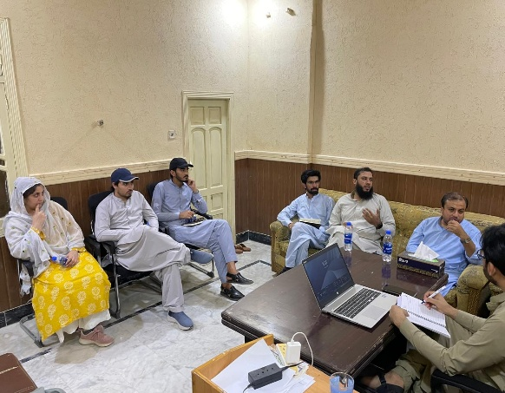
The IP’s District Coordinator was found to be active and effectively managing the team and field-level activities. However, despite these efforts, the pace of withdrawals remained limited due to the presence of only one functional local bank branch. This operational bottleneck significantly slowed the disbursement process, affecting overall construction progress in the area. Additionally, the availability of skilled labor remained constrained, and the considerable distance between construction sites and the bank created logistical challenges for beneficiaries.

Construction Work:
By June 2025, a total of 412 housing units/beneficiaries were targeted under the housing subsidy grant. Of these, 368 beneficiaries had received the first tranche, while only 49 had received the second tranche. Construction progress corresponded with the disbursement pattern approximately 180 houses had reached the plinth level, and 70 had progressed to the lintel stage.
However, the pace of construction has been significantly impacted by operational delays in fund disbursement. Banks were processing withdrawals for only around 15 beneficiaries per day due to workload from Jafferabad. To meet the target of completing disbursements for all 412 households by June 2025, 1,231 withdrawals are still required, which cannot be achieved without 37 per day withdrawal at the bank level.

Village Reconstruction Committees (VRCs):
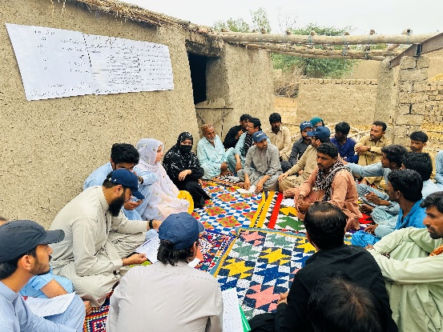
The Village Reconstruction Committee (VRC) was found to be active and engaged. Members regularly maintained their meeting register and played a supportive role in assisting vulnerable beneficiaries with construction activities, reflecting strong community ownership and collaboration.

District Jaffarabad
Project Implementation Partner (PIP): Islamic Relief
Lot # 8

Community Mobilization:
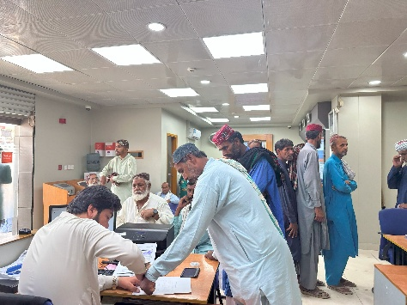
In District Jaffarabad, particularly in the UC Cattle Farm and adjacent areas, beneficiaries expressed overall satisfaction with the support provided by the Implementing Partner (IP), Village Reconstruction Committee (VRC), and the bank. Notably, tree plantation activities were observed alongside ongoing house construction, reflecting community-driven environmental efforts. However, challenges such as water scarcity and certain coordination gaps among stakeholders continued to affect the pace of implementation.

Construction Work:
By June 2025, a total of 2,321 housing units/beneficiaries were targeted under the housing subsidy grant. All beneficiaries had received the first tranche, while 1,489 beneficiaries received the second tranche, 626 the third, and only two had received the fourth tranche. Construction progress aligned with the disbursement trend, 700 houses had reached the plinth level and 270 progressed to the lintel stage. Field engineers provided timely supervision, and construction was generally in accordance with technical specifications.
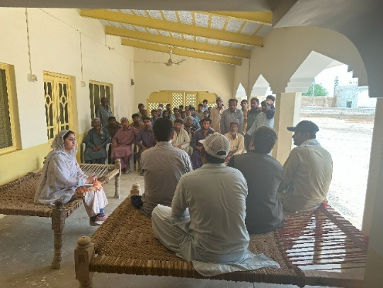
Currently, the average daily withdrawal rate from banks is around 100 beneficiaries. To complete disbursements for all 2,321 households by June 2025, a total of 4,846 withdrawals are still required. At the current pace, achieving this target will be challenging; however, if the average daily withdrawal rate increases to approximately 146 beneficiaries, the target remains attainable within the given timeframe.

Village Reconstruction Committees (VRCs):
VRCs in Jaffarabad, particularly in UC Cattle Farm, were relatively well-organized. Meetings were conducted regularly, though complex member compositions still posed coordination challenges.

District Kachhi
Project Implementation Partner (PIP): Taraqee Foundation
Lot # 5

Community Mobilization:
In Haji Shar village, the presence of the Implementing Partner (IP) was limited, with no senior representatives engaging directly with the community. The District Coordinator had recently joined and was not present on the day of the visit, contributing to a lack of coordination at the field level. Frequent changes in this key position have disrupted continuity and affected oversight. Additionally, field staff did not receive proper training, which further impacted on the quality of engagement and implementation.
Furthermore, the community is facing significant difficulties due to the long distance between their village and the nearest local bank branch, which has made accessing financial services challenging. In addition, the high cost of construction materials has placed a further burden on beneficiaries. Both factors have created substantial barriers to effective community mobilization and have contributed to delays in construction progress. It was observed that the Regional Coordinator (RC) of HRU is actively supporting field operations, providing necessary guidance and oversight, particularly as the IP District Team Lead has only recently joined. This interim support is helping to maintain continuity and facilitate ongoing implementation activities during the transition period.

Construction Work:
By June 2025, all 35 targeted beneficiaries had received the first tranche under the housing subsidy grant. Of these, 18 beneficiaries had completed plinth-level construction, while only 5 houses had progressed to the lintel stage.
Progress was hindered by a lack of ownership and proactive engagement from the Implementing Partner (IP), as well as logistical challenges in the area. Notably, the IP team was not fully aware of the exact total beneficiary target in the locality, which reflects a gap in coordination and planning. However, through field discussions, the above information was extracted to assess the situation on the ground. The average daily withdrawal rate at the local bank stood at approximately 10 beneficiaries, further contributing to delays in disbursement and construction progress.

Village Reconstruction Committees (VRCs):
The VRC in Haji Shar lacked training and formal engagement. Coordination with the IP and banks was weak, and the committee’s oversight function was minimal.

Recommendations:
1. Strengthen IP Coordination
- Conduct regular coordination meetings between Implementing Partners (IPs), and banks at the district level to resolve operational bottlenecks.
- Enforce weekly progress reporting by IPs, covering tranche disbursement status, documentation completeness, and grievance redress activity.
- IPs with low performance should be made accountable as their performance is directly linked with Project success.
2. Improve Bank Engagement
- Manage Beneficiary Flow: IPs must coordinate beneficiary visits in a phased manner. As noted by bank officials, sending all beneficiaries at once causes significant operational challenges. A structured scheduling system should be introduced, assigning specific time slots to beneficiary groups. Additionally, visits should be limited during the beginning and end of each month to avoid overlaps with peak banking periods, particularly salary disbursement days.
- Place dedicated bank focal persons at high-load branches to streamline communication and reduce beneficiary wait times.
3. Prioritize Active Construction Sites
- Fast-track tranche disbursements for beneficiaries who have reached or are nearing plinth-level completion.
- Field teams should be emphasized to upload prioritized construction sites on MIS at the earliest, and the Quality Assurance team should expedite certification of these sites to facilitate timely tranche disbursements and avoid unnecessary delays.
4. Build IP Field Capacity
- Ensure timely onboarding and retention of District Coordinators (BRSP) to support decentralized implementation.
- Conduct structured training sessions for all field-level IP staff to enhance their understanding of technical requirements, documentation protocols, and grievance redress processes. While it was not the HRU’s responsibility to provide continuous field-level support, they have been doing so for the betterment of the project. However, this role rightly falls under the mandate of the IPs and should be fulfilled accordingly.
5. Revitalize Village Reconstruction Committees (VRCs)
- For the next phase of housing construction, geographically proximate beneficiaries should be clustered to enhance VRC functionality and improve the effectiveness of progress. This approach will facilitate better community mobilization, smoother disbursement processes, improved coordination, and more efficient monitoring.
- Actively monitor VRC activity logs and introduce accountability mechanisms to ensure consistent performance.
6. Enhance GRM Access
- Install visible and durable GRM signage in all active communities with contact details and complaint procedures.
7. Address Field Constraints
- Facilitate bulk procurement options or regional price negotiations for core construction materials to reduce overall costs for beneficiaries.
8. Introduce Performance Incentives
- Recognize and reward high-performing VRCs, IP field teams, and bank branches for exceptional service delivery.

Communication

1. Introduction
This section presents consolidated, actionable communications recommendations for the Integrated Flood Resilience and Adaptation Project (IFRAP), derived from:
- The Communications Strengthening Meeting held on 5–6 May 2025 in Quetta, and
- The FPMU Field Visit Monitoring Report (7–10 May 2025) covering five operational districts in Balochistan.
It aims to strengthen communications frameworks, improve operational coordination, enhance content collection, and amplify project narratives that reinforce transparency, accountability, and people-centered resilience stories.
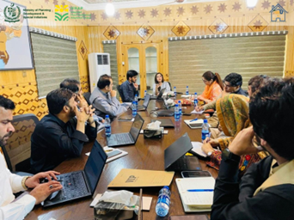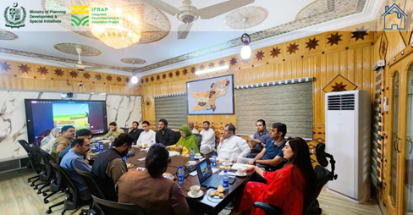

2. Integrated Communications Priorities
- Enhance real-time, structured communication among Regional Coordinators (RCs), Project Implementing Partner (PIP) focal persons, and field teams.
- Prioritize human-centered, authentic storytelling showcasing community resilience and local leadership in reconstruction.
- Address field-level communications gaps at banks, IP offices, and community gatherings through visible signage, clear beneficiary instructions, and active VRC engagement.
- Expand local and regional media engagement to improve project visibility and public trust.
- Standardize and enforce content submission protocols and quality benchmarks for field visuals and reports.

3. Key Communications Recommendations
Recommendation | Source | Action Required
Maintain and monitor active WhatsApp Coordination Groups for daily operational updates, issue resolution, and content sharing. | Quetta Meeting | RCs & PIP focal persons to ensure active use and document summaries weekly.
Develop and disseminate a standardized communications toolkit (reporting templates, content guidelines, messaging protocols). | Quetta Meeting | Communications Specialist to ensure all IP field teams are trained in toolkit use which is already disseminated.
Collect a minimum of five verified, people-centered case studies per district per quarter. | Quetta Meeting & Field Report | RCs to track and submit quarterly; FPMU to review and highlight top stories.
Organize local media orientation sessions in each cluster to foster accurate, responsible reporting on project progress. | Quetta Meeting | Communications Specialist with RCs to plan monthly sessions starting June 2025.
Conduct monthly capacity building workshops on ethical storytelling, videography, photography, and beneficiary consent protocols. | Quetta Meeting | Communications Specialist to deliver sessions via virtual or district-based visits.

4. Monitoring & Reporting Structure
Activity | Frequency | Responsible
Overall Communication progress review | Weekly | Communications Specialist
Content submissions review | Monthly | RCs & Communications Specialist
Communications KPIs report | Quarterly | Communications Specialist

5. Conclusion
By integrating insights from both the Communications Strengthening Meeting and the FPMU Field Visit, these consolidated recommendations document offers a practical, actionable roadmap to bolster IFRAP’s communications infrastructure. Its implementation will bridge operational gaps, empower communities, and amplify resilient housing recovery stories from Balochistan’s flood-affected districts.

Approx 33 days reaming till June 2025.

